Annual Report of the
Board of Governors of
St. Teresa’s Nursery School

2021/22

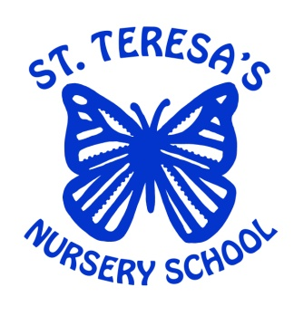

The Board of Governors is required to give parents an Annual Report so that they know what is happening in the Nursery School.

Clearly the report cannot cover every aspect of school activity. If there are any issues which you feel to be important please contact the Principal who will notify the Board of Governors.

As an Eco School – this report will be available on School Website but if you wish a copy please ask the Principal

Organization and Management

The Board of Governors of St. Teresa’s Nursery School has overall responsibility for the management of the school.

The Board of Governors consists of four nominees of the Trustees, two of the Belfast and Education and Library Board, one of the Department of Education, an elected Parent Governor, the Teacher Governor and the Principal.

Membership of the Board of Governors for 2021/22 is detailed below:

Trustee Nominees
Mr. Tim Attwood (Chairperson)
Rev. Fr. G. Lyons
Mrs. Margaret McClenaghan
Mrs. Jacqui Austen

EA Nominees
Mrs. Nicola Donnelly
Mrs. Leslie--Ann Christie

Department Nominee
Mrs. Ann Molloy

Parent Representative
Mr. Gareth McKenna

Teacher Representative
Mrs. Marie-Claire Mcilroy

Principal
Mrs. Clare Evans

The Governors have particular responsibilities in relation to:

- the curriculum
- pastoral care with specific reference to safe guarding
- open enrolment and admission procedures
- behavior management
- financial procedures
- the appointment of staff
- the school building and site.

Management Structures

The present Board of Governors has worked closely with the principal to further develop a framework of management for the school. This is in keeping with developments in education policy and takes account of particular issues affecting our school.

In order to discharge our responsibilities effectively we operate a number of sub-committees:

Finance
- Rev. Fr G Lyons
- Tim Attwood
- Mrs. Ann Molloy
- Mrs. Margaret McClenaghan

Health and Safety
- Mrs. Ann Molloy

Child Protection
Tim Attwood
Mrs. Margaret McClenaghan
Mrs. Clare Evans
Mrs. Marie-Claire McIlroy
Mrs. Lesley-Ann Christie (Governor for CP)

SEN
Tim Attwood
Mrs. Clare Evans
Mrs. Nicola Donnelly (SEN Governor)

Admissions
Tim Attwood
Mrs. Margaret McClenaghan
Mrs. Clare Evans
Mrs. Marie-Claire McIlroy

Appointments
- Tim Attwood
- Mrs. Margaret McClenaghan
- Mrs. Nicola Donnelly

Disciplinary and Grievance for Teaching Staff
- Tim Attwood

Disciplinary and Grievance for Non-Teaching Staff.
- Tim Attwood

It was the intention of St Teresa’s Nursery that all children would receive the highest quality of pre-school education possible, within the provision of excellent learning and teaching opportunities, both in the pre-school and if necessary, in the home learning environment. We recognized that during the COVID 19 Pandemic that this would be challenging. Re-opening after Covid, we understand the impact the pandemic may have had on our new intake.

Prof. Barry Carpenter (Ofsted Report 2020) highlighted 5 key losses:

- Of Routine: regression e.g. toilet training
- Of structure: of pencil grip, holding a knife and fork
- Of friendship: loss of social interaction, children playing in silence
- Of opportunity: mental distress, self-harm/eating disorders
- Of freedom: loss of stamina and of physical illness

School Development Plan 2021/22

The safety of the children and staff remains the priority but will be balanced with approaches that facilitate the continuity of play-based learning experience, appropriate to the ages and stages of the children’s development, in line with NI Curricular Guidance for Pre-School Education.

Areas to be considered as recommended by Department of Education:
• supporting the physical, mental, and emotional health and well-being of pupils and staff.

• developing effective approaches to remote/blended teaching, learning and/or assessment.

• developing effective approaches to delivering services to vulnerable learners and those learners who have statements of special educational need.

• identifying and addressing underachievement, particularly for those pupils who have experienced barriers to engaging in remote learning.

• enhancing parental engagement to support their child’s learning; and

• developing an effective programme of professional learning for teacher/staff

Following public health guidance, the school will operate protective bubbles. A protective bubble will be one nursery class with consistent adults where possible, 5 days a week. After a period of induction, normal in any given year, children will be in nursery full-time with a hot meal provided daily. There will be limited contact between classes and resources indoors will not be shared throughout the day. The timetable will be adjusted to offer extended periods of play outdoors with time for cleaning before use by another class bubble. We will seek to obtain funding to develop the outdoor space so both classes can be out at any one time without mixing bubbles, reducing time spent cleaning. Whilst the classroom and whole nursery building will be organized to encourage children to distance it is not expected that children will practice social distancing.

If circumstances change due to COVID 19 the Nursery will be prepared to revert to remote/blended learning approaches with immediate effect.

DE Education Restart Guidance (17/08/2020)
“Given the changing public health position it is now appropriate that such (protective) ‘bubbles’ are based on whole classes, facilitating the safe return of pupils to education on a full-time basis”

AREAS FOR CONSIDERATION
- Communication-with all stakeholders
- Creating- space for a safe learning environment
- Curriculum- delivery

- COMMUNICATION

The provision of a two-way communication system was key to the management of the pre-school during 2021/22 academic year.

It was important that as a school we follow the latest information and guidance from the DE, EA, and DoH and to communicate this with all of the Nursery team and as a staff, agree approaches to the implications for the Nursery. With limited face to face contact with parents and families due to staggered start and finishing times, social distancing and the recommendations form the EA that parents do not enter the school building unless considered an exceptional circumstance, we must demonstrate empathy and increase parental confidence by offering other means of communication if Restart is to be a success.
Communication with parents:
- Letters/Induction Booklets to inform parents of how Restart will look like in our setting including latest EA and PHA guidance.
- Gathering of information on children’s previous experiences.
- Update relevant policies in line with EA guidance ad share with Parents e.g., School Prospectus, Child Protection, Intimate Care, Medical Condition/ Common illnesses/COVID 19 signs and Symptoms.
- Use Seesaw, Facebook, and School Website (new this academic year) to update parents on Children’s performance, send notifications, newsletters etc.
- Sharing of virtual tours of the indoors and outdoors of the Nursery.
- Directing parents to websites such as GRTL, EA Support learning, Parental Engagement Services and EA SEN Early Years Inclusion Service.
- Remote induction and curriculum meetings.
- Support parents who might find remote/blended learning difficult to manage.
- Literacy coordinator to link with parents with regards to concerns in speech and language development.
- Ensure ongoing observations systematically recorded using iPad, and ready to share as an iBook with parents highlighting children’s performance, achievements, and progress.
Communication with others:
- Communicate with other Nursery leaders (West Belfast Nursery Area Learning Community) to share effective practice.
- Engage with ETI District Inspector, EA link officer and CCMS for support.
- Liaise with School Psychology and other Health Professionals (Health Visitor, Speech and Language Therapist) to ensure children receive appropriate support and risk assessments are in place and appropriate IEPs.
- Ensure that support is accessed through EA learning portal.
- Communicate with Governors’ the challenges and priorities as a direct result of pandemic.
Communication with staff:
- Communicate with staff using email, or phone when not in school to advise on Executive directives, and PHA guidance on Restart.
- Ensure that all staff meetings at the beginning of the school term are socially distanced and that any collaboration prepares staff for the planning process of the Restart.
- All key protection and hygiene training measures to be communicated and applied in line with latest PHA guidance and understood by staff to minimize the spread of infection. (Training completed-COVID Awareness training, Donning and Doffing of PPE and Child Protection AUG 2020, certificates obtained).
- Ensure compassionate leadership as staff may have real concerns and anxieties regarding the safe return to school.
- Individual meetings with staff members to alleviate fears and to complete risk assessments for those staff members considered clinically vulnerable, clinically/extremely vulnerable or living with a family member considered clinically vulnerable, clinically/extremely vulnerable, or previously shielding.
- Communication by staff with caring responsibilities.
- To ensure staff are signposted to the relevant School Development Services to support wellbeing which will be displayed in school. (Inspire Workplaces 0808 800 002)
- Share all factual, information from PHA, EA, EYO, and HSCT to decrease fears and anxieties and to enable staff to be prepared with coping with Restart.
- Create an ethos and atmosphere in the preschool setting that allows staff to talk, relax and have time out from an atmosphere which is uncomfortable.
- Signpost staff to guidance that outlines, procedure and protocol if they are in contact with a positive case, in class bubble, at home, have been contacted by track and trace or have symptoms of COVID 19.
- Allow staff time for reflection on personal experiences during lockdown and have conversations about the development of the good practice that already existed and how this can be carried forward.
- Share with staff the need to use social media to share information and ensure they have some understanding of how to use or gain access to information sharing. E.g. School Website, Seesaw, Facebook.
- Ensure staff are equipped to offer remote/blended learning with immediate effect. This will be conducted on Evidence Me and See Saw.
- Celebrate the success of what is new practice and develop and incorporate this practice into future School Development and future delivery of the pre-school curriculum and methods of communicating with parents/carers.

Communicating with children. (recognizing the settling in period may be a challenge)
- Welcome photos of setting, staff, and video messages from class teacher. (Seesaw)
- Opportunities for children to upload photos and share likes, dislikes and favorite toys.
- Virtual tours of the building indoors and out.
- Starting school, rhymes, stories, and information from GTRL.
- Share information on handwashing and hygiene routines, (Rufus) so children have some understanding on what to expect first days.
- Staggered drop off and pick up times to ensure social distancing and to allow staff one to one time with children.
- Establish early morning routines, leaving parent/career at door, handwashing on entry and leaving all belongings at the door and continue throughout the academic year to embed as the ‘new norm’
- To ensure signage and markings in the school help the children not only feel welcome but ensure they understand the need for hand washing/sanitizer on arrival, social distancing while waiting to be brought into school and why some adults may wear masks.
- To ensure that temperature checks are fun rather than frightening. ‘Beep-beep’ song.
- Blended learning to be in effective immediately if a child is absent from school isolating Observations and assessments will heavily focus on PSED first term.
- Children requiring additional support or are struggling emotionally, academically or have delay in speech and language will be directed to supporting agencies.
- Ensure that the well-being of the children is a priority and that school experiences are not overshadowed by the anxieties of COVID. We want out children’s experience in St. Teresa’s Nursery to be ‘the best that it can be’

GPDR and E Safety Guidance will be adhered to through all communication.

2 Creating Space for the Learning Environment

The staff of St Teresa’s Nursery recognize that the pre-school learning environment of the ‘new norm’ will require creative adaptation and careful planning to simultaneously provide a rich, stimulating learning environment that offers a broad and balanced pre-school curriculum whilst adhering to PHA guidance. It also recognizes the need to promote an inclusive learning environment where all learners have access to high quality provision and academic achievement and the wider skills and dispositions that learners require to live and work in the world today will remain a priority. The safeguarding/child protection and well-being will be core in the care and welfare of learners and will be visible and paramount every academic year and during this Pandemic.

The process of self-evaluation will reflect, lead to improvement, provide areas of strength, identify areas that require development and the actions that are necessary to continue to improve. This academic year it will require a wider, more inclusive, and objective perspective, that can be presented to parents, and the wider community in dealing with the COVID 19 pandemic and the challenges it brings. As school it is our aim to work to the best of our ability to make it work, to adapt new practices that may challenge us and embrace that change may benefit the learner in other ways! We fully understand that adopting safety measures to decrease transmission will affect most of the daily routines and timetables and as a school we must be prepared for this.
Effective Practice ISEF
- Quality of provision
- Leadership and Management
- Care and Welfare
As a staff we must self-evaluate the available indoor and outdoor space and maximize its potential for safe and qualitative teaching and learning with learning outcomes of a high standard. We recognize the need to review and update existing policies and procedures in line with current guidance from relevant organizations, DE, EA, PHA and DoH. We will endeavor to ensure that all children are supported to overcome barriers in learning we will always demonstrate the pre-schools capacity to have a caring ethos with all staff committed to the care and welfare of the children.

Updated policies

- Pre-School Curriculum Polices
- Risk Assessment
- Roles and Responsibilities of staff
- Code of Conduct
- Health and Safety
- Intimate
- Care
- Safeguarding and Child protection
- Induction/Settling in
- School Visitor Policy
- Behavior Management
- E Safety
- Evacuation Procedures

3 Curriculum delivery

As a pre-school we need to consider how best to deliver the curricular guidance considering the emerging needs and interests of the children, including the many factors related to COVID 19.

As normal practice the curricular areas will be planned for and reflect the children’s interests. For children with SEN or LAC information will be gathered and shared with relevant professionals and there will be sensitive gathering of information from parents for those children who have been directly affected by the Pandemic.

Whilst offering face to face teaching 5 days a week we will be prepared for remote/blended learning approaches. The effective use of digital technologies will foster collaboration between home and the pre-school and strengthen relationships between, staff, parents, and children. Blended approaches will focus on promotion of digital and non-digital access to a range of activities. As a school we will review and evaluate remote and blended approaches and ask reflective questions.

Promoting the personal and social needs of the children will take precedent and staff need to recognize that whilst some children may need emphasis on PSE others will adapt and will require challenge. Planning will reflect these differences.
For the purposes of delivering the Curriculum to the highest of standards it is our aim and vision to continue the process of self- evaluation and self-reflection, to have professional discussion around the Restart, stimulating the debate around the outcomes for learners, quality of provision, and leadership and management. It will also help us to reflect on development needs, skills, and expertise, in pursuit of high-quality teaching and learning whilst dealing with a Pandemic.
Areas of consideration are outlined in attached Action Plans 2020/21

In line with the Department of Education Regulations the school operates a Three-Year School Development Plan.

In essence the School Development Plan is a strategic plan for improvement. It brings together the school’s priorities, the measures it will take to raise standards and the targets it intends to achieve.

The School Development Plan 2019-2022 is available in the nursery school. Parents who are interested in further information are asked to contact Mrs. Evans

Area of Development | 2021/22
Leadership and Management | To monitor – Transition/Communication to and from nursery
Governors | Reconstitute BOG  Appoint new Trustee governor  Appoint Governor SEN  Audit Training
Curriculum & Assessment | Review CCTV, Anti-bullying and SEN  policy  Undertake and Calm Plan Programme
Pastoral & Ethos | Review staff wellbeing and embed coaching
Staff Organization & Development | Evaluate staff understanding of SEN re: new SEND recommendations
Special Needs | Discuss new model for SEND  Reasonable adjustments – risk assess transition for Butterflies
Health and Safety | Renew First Aid Training November 2021  Cleaning Audit  COSHH
Parents | GRTL – Parent Workshops. Big bedtime read, Happy Healthy Kids, Ages and stages, Education works in pre-school.  Curriculum Meeting in light of revised Pre-school Curriculum  Monthly Services – Thank- you God…  Increase SEESAW participation (offering paper copies for parents who need it
The School & Community | Keep links with Shaftsbury Nursery School despite shared education programme coming to end  Deliver training Area Learning Community – Attention Autism, Lego play therapy, WellComm, Makaton and 6 Bricks
Accommodation & Maintenance | Install new sensory room and blinds  Repaint inside of school, following upgrade works to electrics (still outstanding)
Finance/Budget/Human Resources | Appoint finance committee  E. T – permanently moving to 4 days a week  Employ J. C for 1 day a week and employed through extended schools for rest  Next year: retaining 3 CA 22.5hrs each

Funding

Financial Report
The Board of Governors has overall responsibility for the budget, but on a day to day basis responsibility is exercised by the Principal.

The budget is calculated by the Education Authority Belfast region- using a formula which applies to all schools in the area. The main element in the formula is the age and number of pupils attending the school. Other factors taken into account include special needs and factors relating to the size and design of the building which affect running cost.

Funding

Getting Ready to Learn Financial Allocation 2020/21

Big Bedtime Read
Monitoring and Evaluation Time
Ages and Stages
Education Works in Preschool
Total £950.00

This was spent on Home Learning Packs – top-up of £150 – provided materials e.g. chalks, pencils etc. to supplement this during the year.

£300 funding from WBPB – awarded to fund Environmental Parent Project.

The LMS Three Year Financial Year is detailed below:

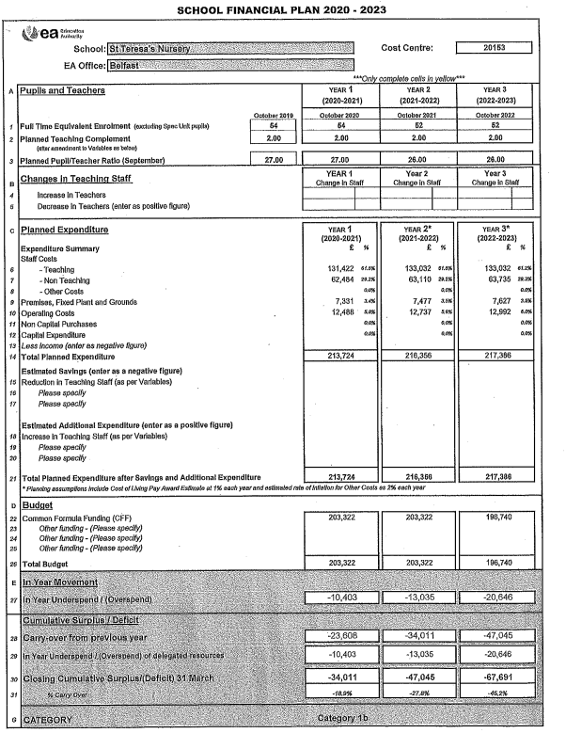

Extended Schools

During 2020/21 the school operated a restricted Extended Schools Programme but still involved and was beneficial to both children and parents.

The programme provided the opportunity for the children to engage in a range of activities both during and after the school day. There was a very high level of participation in after schools’ activities such as our gardening and story sessions.

The activities clearly extended the children’s experiences. The programme also gave parents the opportunity to participate in activities with their children. Parental questionnaires clearly indicated a very high level of satisfaction with the services offered.

The school was allocated £5683 for the Financial Year 2020/21.

Action Plans will relate to:

- Extended Services during school
- Extended Services after school
- Developing links with parents
- Supporting early literacy
- Joint parent/child activities to support children’s learning
- Engaging parents in the curriculum through transition and schema workshops; and
- The role of the coordinator and extended school’s assistant.

The school also participated in the extended schools Cluster Programme £5181 additional monies were awarded.
Total monies awarded 2020/21 – £10864

Extended Schools Programme 2021/22

Additional funding has been approved for our Extended Schools Programme. As in previous years, action plans will be drawn up and submitted to the Education authority for consideration.

Action plans related to:
- Extended Services after school
- Joint parent/child activities to support children’s learning
- Engaging parents in the curriculum through art and dance and music workshops; and
- The role of the Co-Ordinator and extended Schools Assistant.

. Approximate funding for 2021/22: should remain the same, awaiting confitmation.

The Curriculum

When referring to the curriculum of the Nursery School we are concerned with building on the children’s experiences, matching activities to their needs and providing planned purposeful activities for teaching and learning both indoors and out.

When planning the curriculum, we take into account the way in which the pre-school child develops, that is the development of speech and language, physical skills, intellectual development and social and moral development. Out school takes cognizance of the revised Pre-School curricular guidance document, September 2018.

We provide a broad and balanced curriculum allowing children to make choices and providing them with the opportunities through play to develop the learning associated with:

- Personal, social and emotional development
- Physical development and movement
- The arts
- Language development
- Early mathematical experiences
- The world around us

In St. Teresa's we have a strong focus on meeting the individual needs of the child. We observe children's patterns of behavior (schema's) and plan activities accordingly to maximize children's involvement in their play, enabling them to 'be the best that they can be'.

Since June 2017, we have adopted an Open Plan approach. We had to revert to single classes to reduce cross-contamination between bubbles.

We promote children’s Primary Movements and provide lots of opportunities to develop physically both in the indoor and outdoor classrooms.

Special Educational Needs

In June 1998 all schools received the Code of Practice on the identification and assessment of Special Educational Needs.

Further to this a number of documents have been issued to schools including:

- Special Educational Needs and Disability 2005
- The supplement to the Code of Practice on the Identification of Special Educational Needs 2005
- Disability Discrimination Code of Practice for Schools 2006
- Supporting Pupils with Medication Needs 2008
- Good Practice Guidelines 2009
- Special Needs and Inclusion 2011.

In line with the guidance the school operates a Special Educational Needs and Inclusion Policy. This has been modified to reflect the changing direction following SEND legislation in 2016.

The main thrust of this policy is to meet the needs of all children in
St. Teresa’s Nursery School with Educational Needs/Disability/Additional Educational Needs.

The Special Educational Needs and Inclusion Policy is available in the school. Parents who are interested in further information are asked to contact the principal.

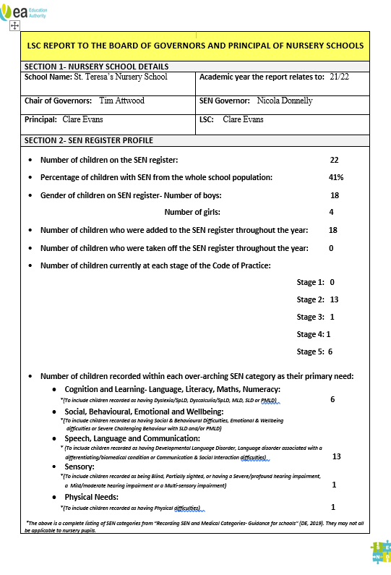

Pastoral Care

As a Gold Rights respecting school, we are committed to the UN Convention on the Rights of the Child (UNCRC). Click this link to see a summary of the UNCRC.
We learn about rights, through rights and for rights. Our aim is to 'create brilliant citizens' and we believe that our pupils are more sensitive and empathetic towards others through learning about children's rights.
As well as our statutory responsibilities in relation to pupils’ learning we have a pastoral responsibility towards the children in our care.

The welfare of the child is paramount. It is our duty to ensure that the children are safe and protected when they are in our care.

“The fundamental principle in child care law and practice are that the welfare of the child (0-18) must always be the paramount consideration in the decision taken about him or her”.

In line with our statutory responsibilities the school has five policy documents relating to pastoral care including:

- Child Protection Policy
- Pastoral Care Policy
- Behavior Management Policy
- Anti-Bullying Policy
- Safe Handling Policy

All Policies were reviewed and updated during 2021/22. Policies are available on the school website. These have been approved by the Board of Governors. A schedule of policy review has been drawn up and will commence in August 2021.

The School Safeguarding Team is as follows:
Mr. Tim Attwood (Chair of Governors)
Mrs. Clare Evans (Designated Teacher)
Mrs. Marie-Claire McIlroy (Deputy Designated Teacher)
Mrs. Lesley-Ann Christie (Governor with responsibilities for Child Protection)

Parents who are interested in further information are asked to contact
Mrs. Evans (Principal)

Health and Safety

In order to ensure the children’s safety while on our premises we operate a controlled access system. The front door of the school is locked from 8.00am until 1.30pm. Entry is only available through pressing a buzzer.

Assessment and Reporting

Knowing how your child is progressing at Nursery School is important. In the school a detailed profile of each child’s development and progress is kept and updated regularly. 2Simple app collates all observations electronically.

Parents do have the opportunity to discuss their child’s needs and progress through:

- Informal daily contact SEESAW
- Open days
- Arranging a meeting with the child’s class teacher as the need arises
- Stay and Play days (these have been suspended during pandemic)
- Formal meetings in October and February (SEESAW 2021/22)
- Transition Report Meeting May (SEESAW 2120/22)

External Relations

The Nursery School is an integral part of the community, thus effective links are maintained with outside agencies and local primary schools.

Good relationships with St. Teresa’s Primary School are most important. This is particularly so with regard to transition. We promote continuity of experience between the Nursery and Primary One.

Part of this process has involved a programme of visits from St Teresa’s staff to the setting to familiarize themselves with the children they will be receiving, the learning experiences the children in the setting are exposed to daily and the observation and assessment process that informs the Transition Profiles they receive in conjunction with classroom visits and handover meetings.

The majority of our children transferred to Teresa’s Primary School however a few children transferred to other primary schools. Transition Profiles were passed on to the Primary One Teachers in the relevant schools.

St. Teresa’s NS is part of the local Nursery Area Learning Cluster. Mrs. Evans Chairs West Belfast ALNC and sits on Strategic Steering Group. Mrs. Evans will be leasing with SureStart settings by Zoom in June to facilitate transition meetings with parents. Mrs. Evans is also Vice-Chair of the Outer-West SureStart Management Committee.

